RTDSP Speech Enhancement Report

**Hao Chun Hsu (hh3413/00809205)**

**Yoshimasa Sano (ys5413/00735209)**

**Declaration: We confirm that this submission is our own work. In it, we give references and citations whenever we refer to or use the published, or unpublished, work of others. We are aware that this course is bound by penalties as set out in the college examination offenses policy.**

**Signed: Hao Chun Hsu , Yoshimasa Sano**

# CONTENTS

# Abstract

# Introduction

# Basic Speech Enhancement

# Additional Speech Enhancements

## 4.1 Low Pass Filter Signal Magnitude

## 4.2 Low Pass Filter Signal Power

## 4.3 Low Pass Filter Noise Magnitude

## 4.4 &4.5 Gain Variation

## 4.6 Noise Level Overestimation

## 4.7 Frame Length Variation

## 4.8 Residual Noise Reduction

## 4.9 Minimum Spectrum over Short Period

## 4.10: Flair

# Conclusion and Main Spectrograms

# References

# Appendix: Full Code and Spectrograms

# Abstract

This report begins by investigating the use of spectral subtraction technique in removing noise from speech signal (i.e. speech enhancement). It then proceeds to improve this technique by varying certain parameters in the programme and testing for best performance on audio files with various kinds of noise. Finally, the report evaluates 9 ways which involved either varying the original algorithm or using alternative ones to investigate whether they improve or worsen the performance of speech enhancement.

# Introduction

Speech enhancement is an important technique in communication systems, as communication equipment such as mobile phones are usually used in noisy environments such as airports, in cars and and workplace. Without attenuating the noise or amplifying the speech signal, the performance of these equipment is significantly reduced as it is often difficult to hear what the other user is saying due to noise. Hence this report will aim to tackle this issue by looking at fast and efficient ways of reducing the noise, giving the end-user a good quality signal.

# Basic Speech Enhancement [1]

The purpose of the basic part of this project is to use spectral subtraction technique to improve the quality of signal transmission by attenuating the noise and/or amplifying the speech signal. The process is shown in the block diagram in figure 1 below.

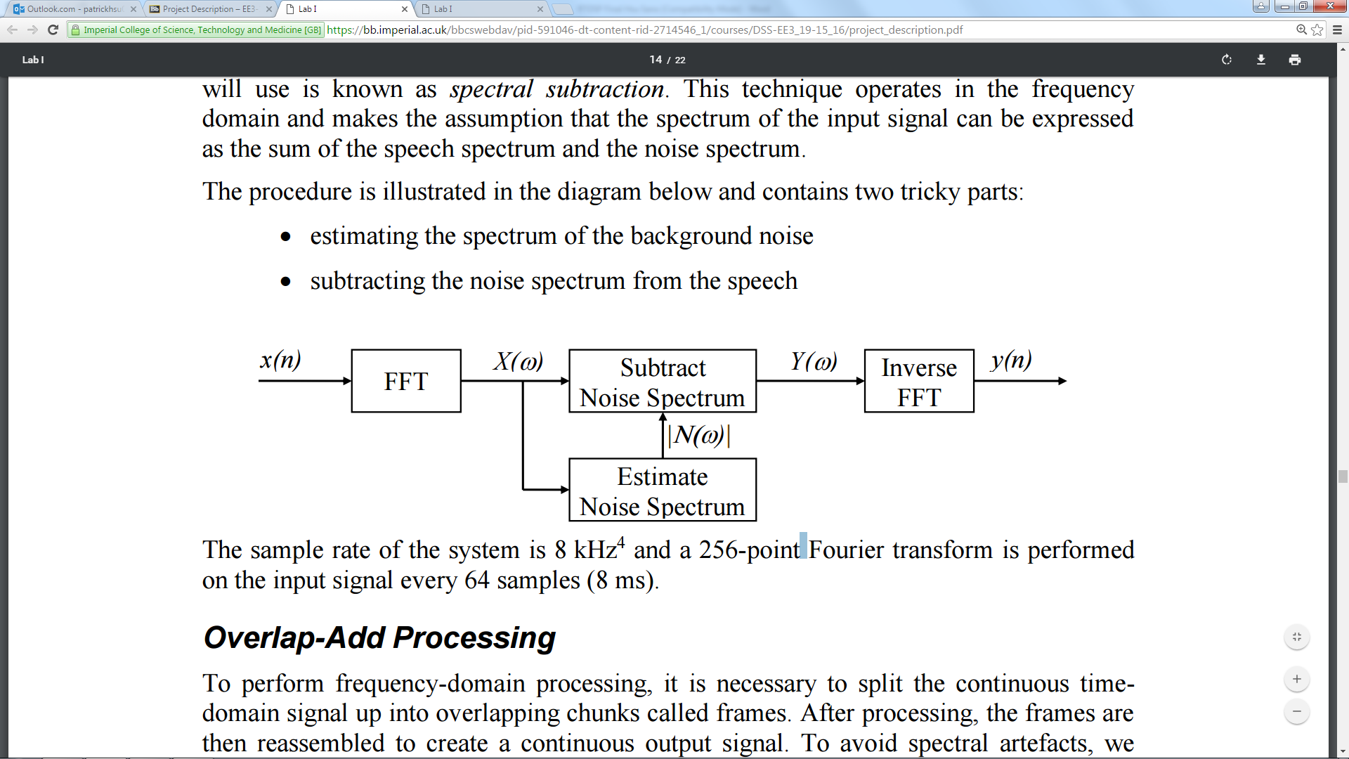

Figure 1: Overall block diagram of noise removal process

**Frame Processing**

First of all, FFT is required to transform the input x from the time domain to the frequency domain for processing. In order to optimize the processing speed, the input is split up into overlapping frames in the time domain. This allows for simultaneous output and input as well as giving a smoother output. Each frame can store 256 samples and the sampling frequency is 8kHz.

In order to make the output continuous by eliminating distortion, the overlap-add procedure is used which sums successive frames each of which has been convoluted with an input and output Hamming window. In addition, an oversampling rate of 4 is used to further reduce distortion by reducing the step size.

**Estimating noise spectrum**

Assuming people do not talk for more than 10 seconds without stopping, we take the minimum power of those 10s and define that to be noise floor, to be subtracted from the speech signal. However, this is not practical because of memory limitation, as we need to store 312 x 4 frames x256.

This can be solved by splitting the 10 seconds into 4 chunks and finding the minimum in each of the 2.5s before comparing them to find the “global” minimum, i.e.

$$M_{1}\left(ω\right)=min⁡(|X\left(ω\right)|,M_{1}\left(ω\right))$$

$$N\left|\left(ω\right)\right|=α\min_{i=1,2,3,4}{M_{1}\left(ω\right)}$$

**Noise Spectrum Subtraction**

Finally we subtract the estimate noise from the speech to derive the output as follows:

$$Y\left(ω\right)=X\left(ω\right)-N(ω)$$

However since the phase of noise is unknown, we deal only with the magnitude, so the equation becomes:

$$Y\left(ω\right)=X\left(ω\right)×\frac{|X\left(ω\right)|-|N\left(ω\right)|}{|X\left(ω\right)|}=X\left(ω\right)×\left(1-\frac{\left|N\left(ω\right)\right|}{\left|X\left(ω\right)\right|}\right)=X\left(ω\right)×g\left(ω\right)$$

To avoid g(ω) becoming negative, which will cause disastrous distortions, we set

$$g\left(ω\right)=max⁡(λ,1-\frac{\left|N\left(ω\right)\right|}{\left|X\left(ω\right)\right|})$$

where $λ$ is typically from 0.01 to 0.1

# Additional Speech Enhancements

## Low Pass Filter Signal Magnitude

The first enhancement involves using the frame-wise low pass filtered magnitude of the input spectrum. The low pass filtered input estimate for frame t is shown in the equation below in figure 2.

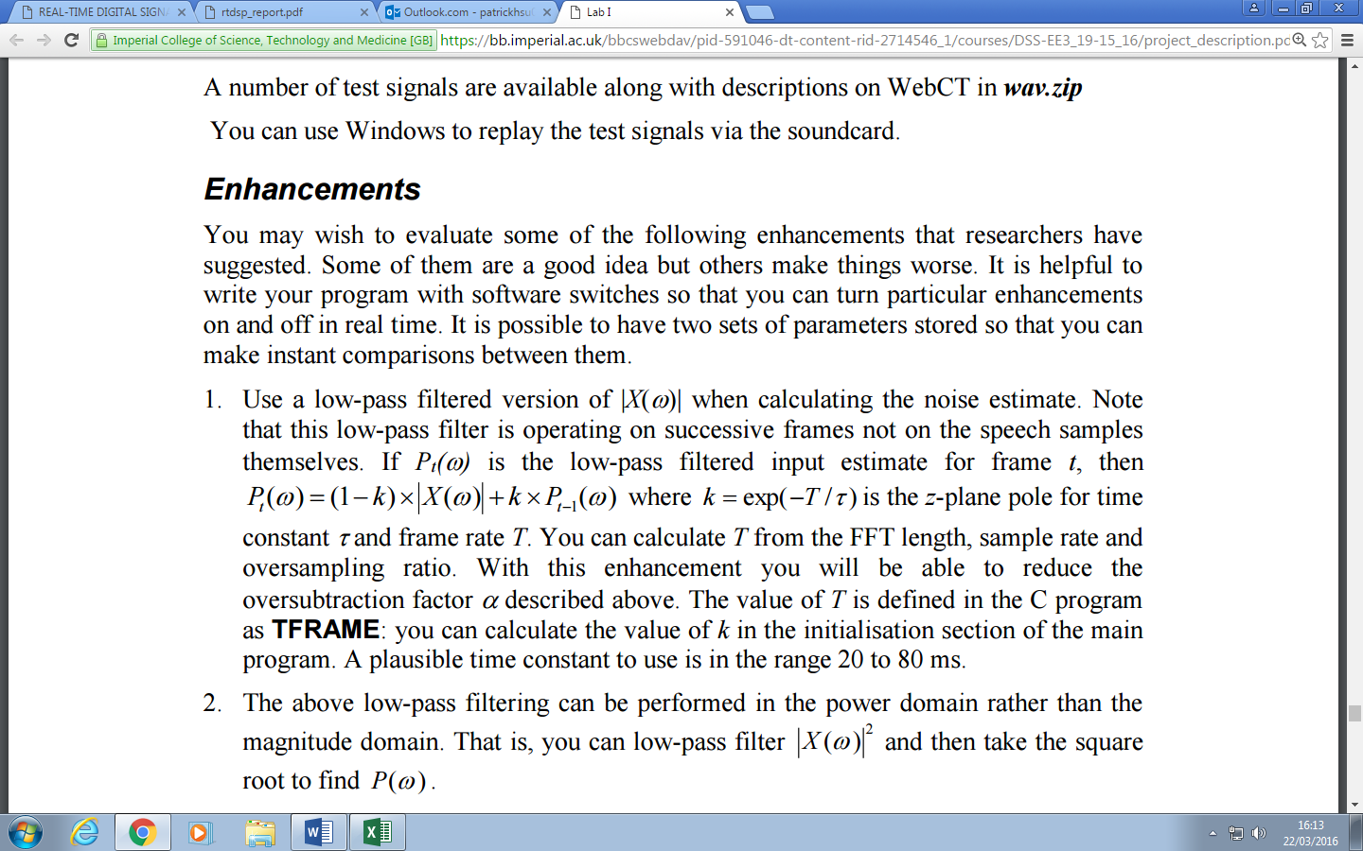

Figure 2: Equation for the low pass filtered input estimate

τ is the time constant to be determined experimentally that ranges from 20ms to 80ms. We found the optimal to be 20ms and he enhancement factor α to be 5.

Our code which implements this enhancement is shown in figure 3 below.

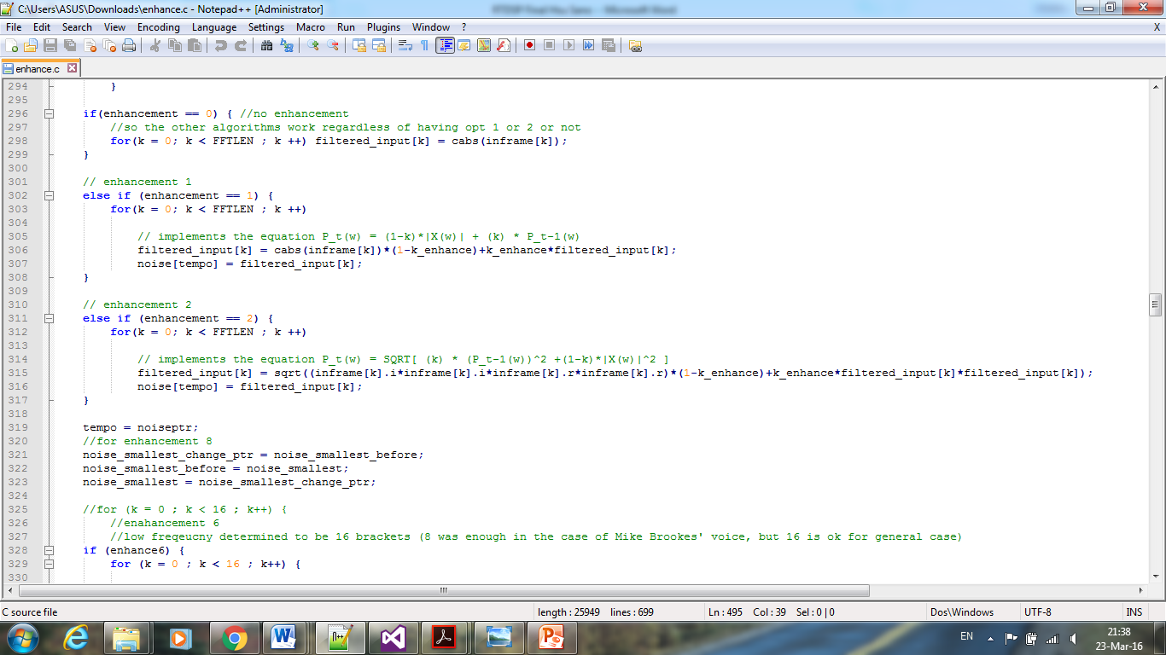

Figure 3: Code snippet implementing enhancement 1

In general, we have found that this enhancement makes the quality of the recordings worse because the high frequency components, which mainly corresponds to speech, are attenuated, while the low frequency components, which corresponds mostly to noise, are undealt with.

## Low Pass Filter Signal Power

This enhancement is similar to the one describe above in 4.1 except that the input power ${\left|X\left(ω\right)\right|}^{2}$ is low pass filtered rather than the magnitude. The square root of the resulting estimate is taken to find Pt(ω), namely:

$$P_{t}\left(ω\right)=\sqrt{\left(1-k\right)×{\left|X\left(ω\right)\right|}^{2}+k×(P_{t-1}{\left(ω\right))}^{2}}$$

τ is the time constant to be determined experimentally that ranges from 20ms to 80ms. We found the optimal to be 20ms and he enhancement factor α to be 5.

Our code which implements this enhancement is shown in figure 4 below.



Figure 4: Code snippet implementing enhancement 2

In general, we have found that this enhancement makes the quality of the recordings better because squaring the spectrum enables better distinction between speech, which is large, and noise, which is small. Therefore, even when the low frequency components which is mostly noise are left intact, squaring them achieves the attenuation effect while amplifying the speech at these frequencies too.

## Low Pass Filter Noise Magnitude

This enhancement is similar to the one describe above in 4.1 except that the noise $\left|N\left(ω\right)\right|$ is low pass filtered rather than the signal, hence the equation becomes:

$$P_{t}\left(ω\right)=\left(1-k\right)×\left|N\left(ω\right)\right|+k×P_{t-1}(ω)$$

τ is the time constant to be determined experimentally that ranges from 20ms to 80ms. The enhancement factor αthat was found to give the best quality was 5.

Our code which implements this enhancement is shown in figure 5 below.

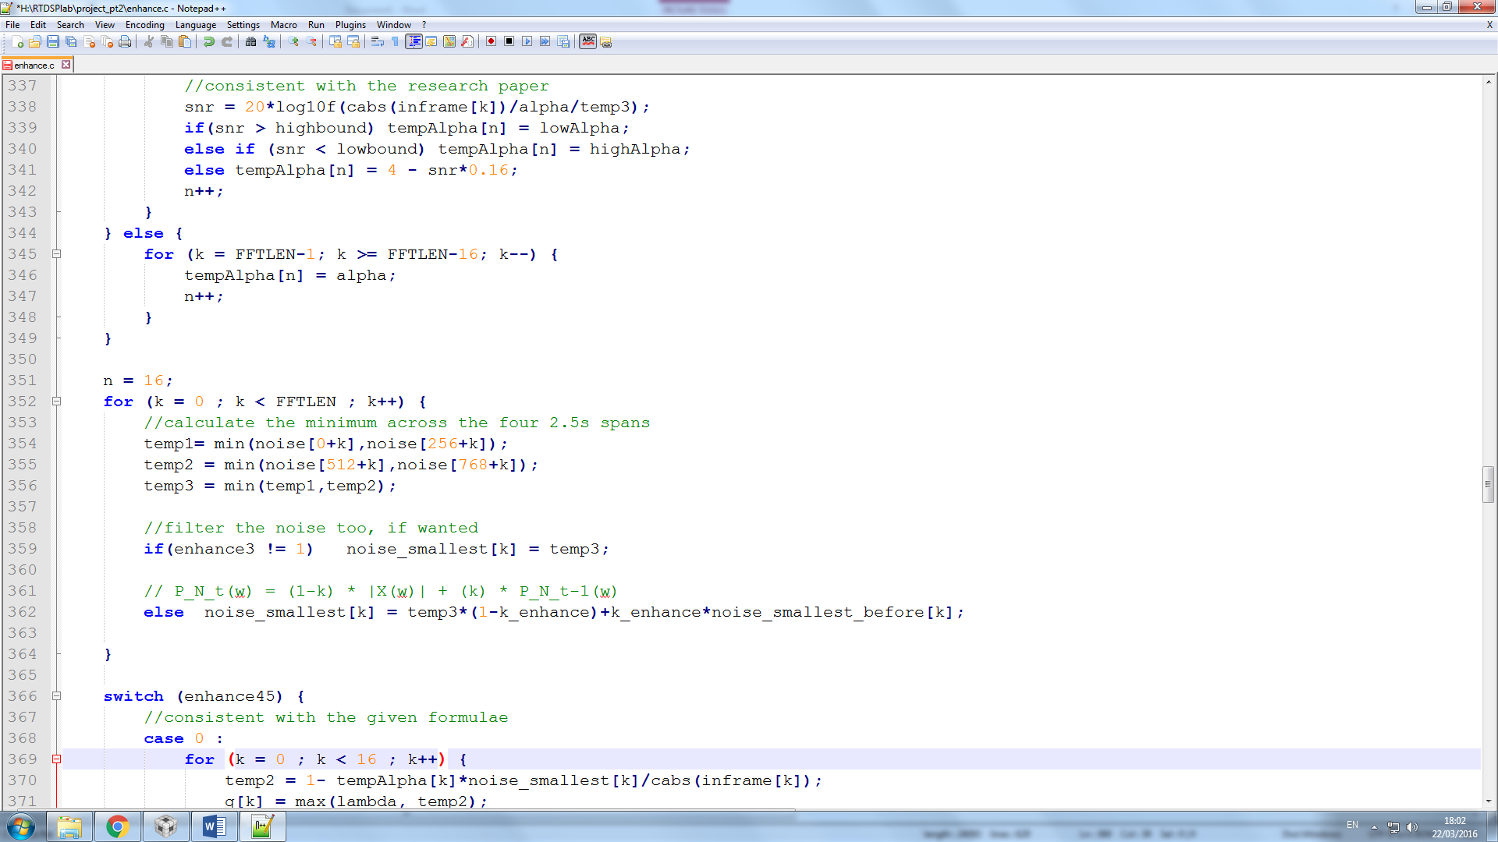

Figure 5: Code snippet implementing enhancement 3

In general, we have found that this enhancement makes the quality of the recordings better. As mentioned in the previous sections, the low frequency components consist mostly of noise, hence low pass filtering the noise here proved effective in removing the majority of the noise.

## & 4.5 Gain Variation

In this pair of enhancements, we investigated the effect of varying the gain g(ω) on the speech quality in both magnitude domain (4.4) and power domain (4.5) for a range of λ. For each domain we experimented with 5 different configurations of setting gain, as shown in table 1 below.

|  |  |  |  |
| --- | --- | --- | --- |
| **Version** | **Magnitude Domain Setting** | **Power Domain Setting** | **Results** |
| **0** |  |  | No effect |
| **1** |  |  | Noise attenuated but new tapping noise was introduced |
| **2** |  |  | Speech was attenuated and overall was worse |
| **3** |  |  | Little effect, speech was slightly attenuated |
| **4** |  |  | Noise significantly attenuated, speech slightly attenuated too but overall is the best out of the five |

Table 1: Settings and Results for 4.4 and 4.5

Our code which implements these enhancements is shown in figure 6 below.

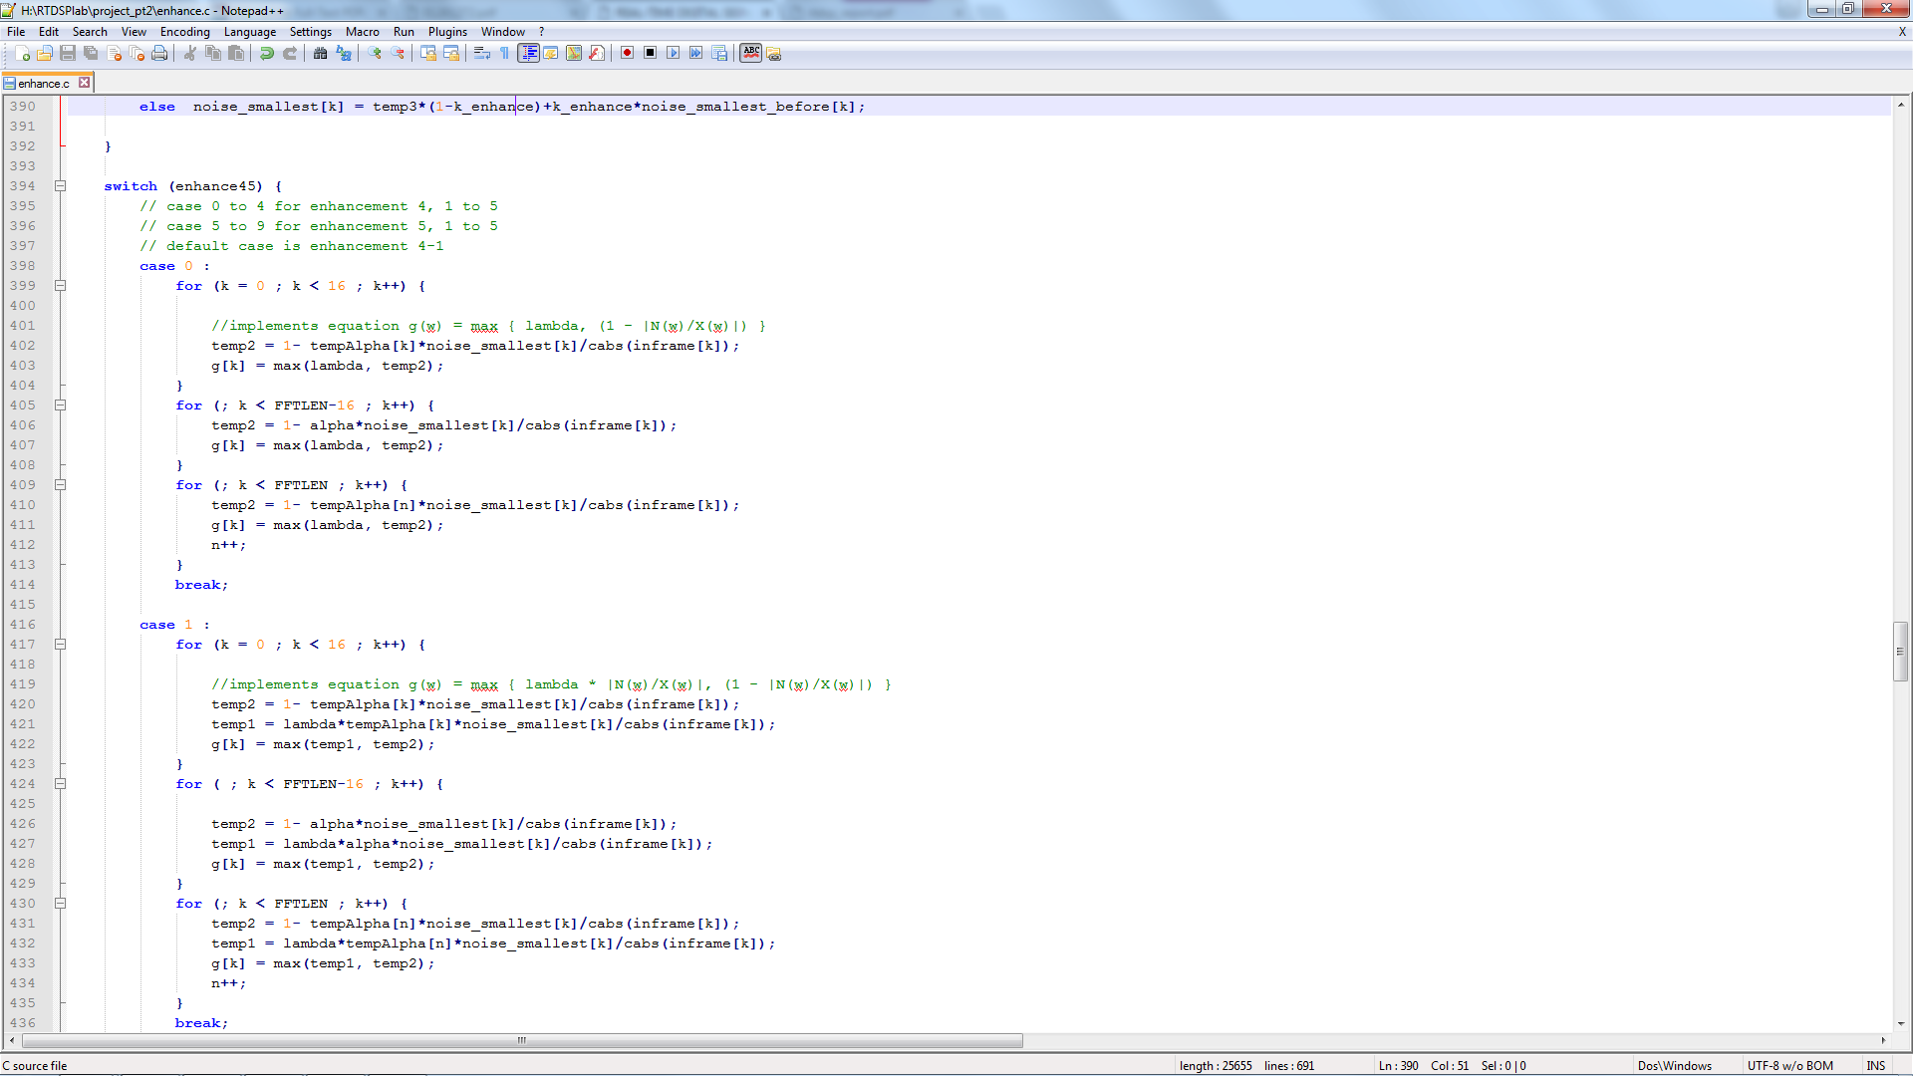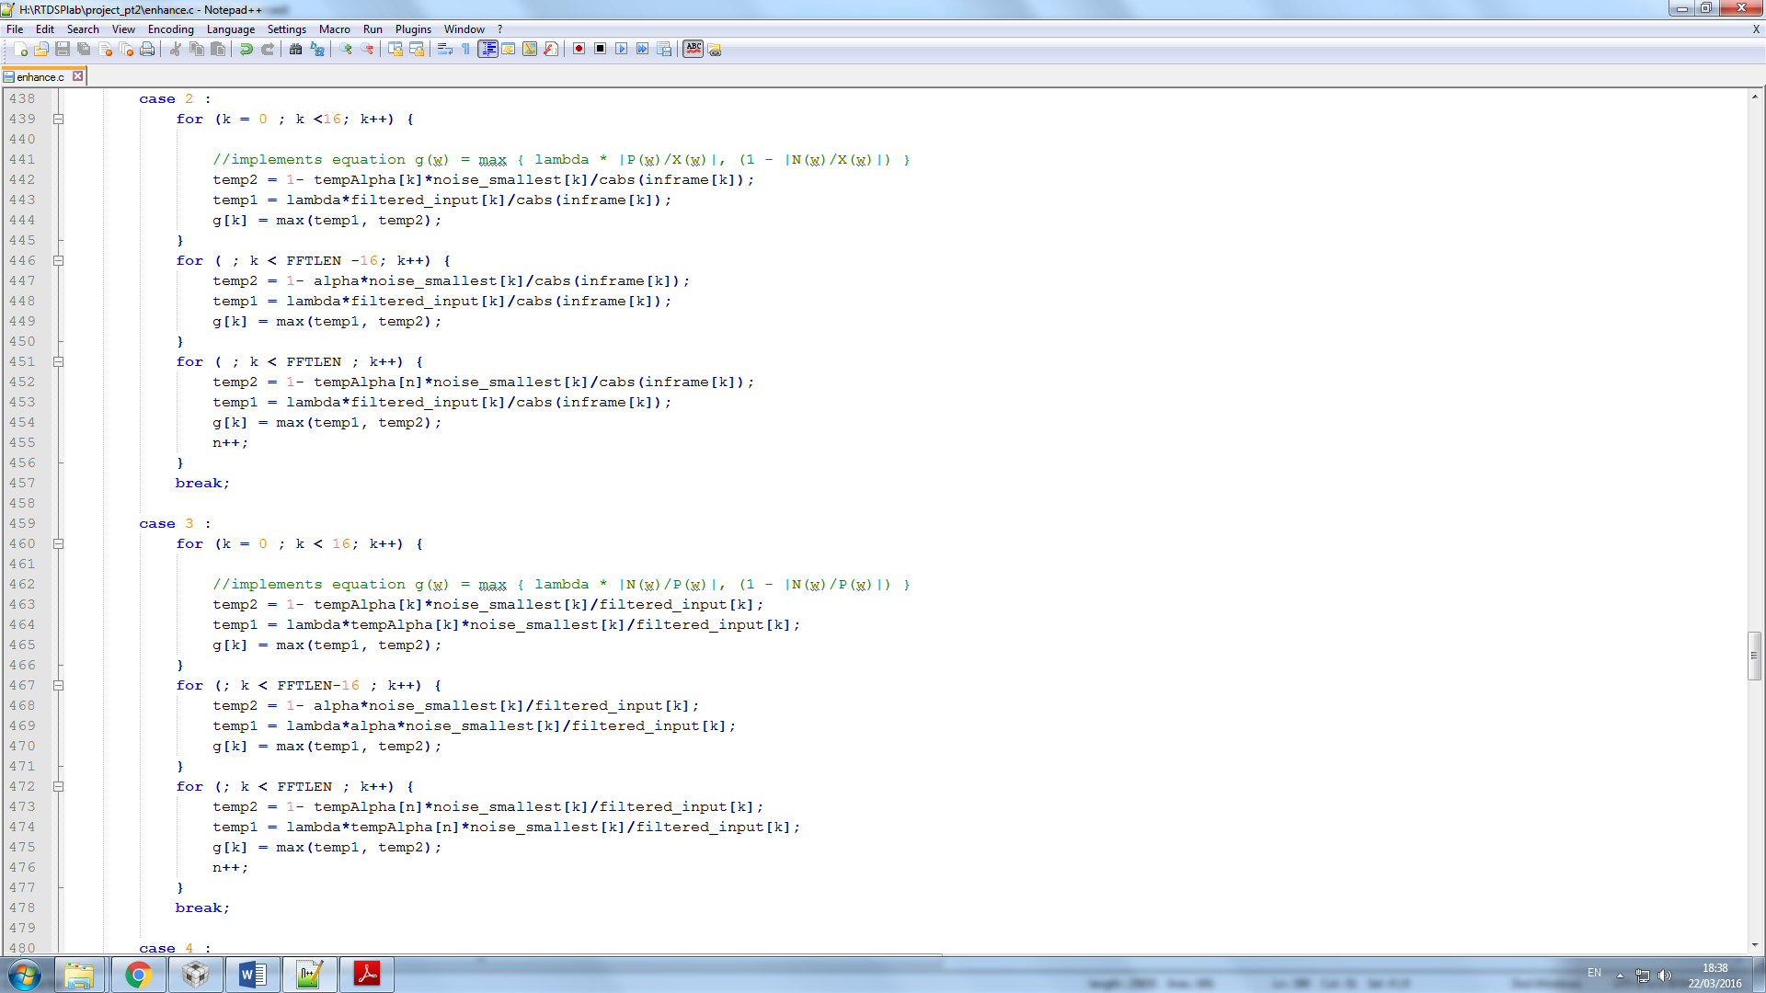

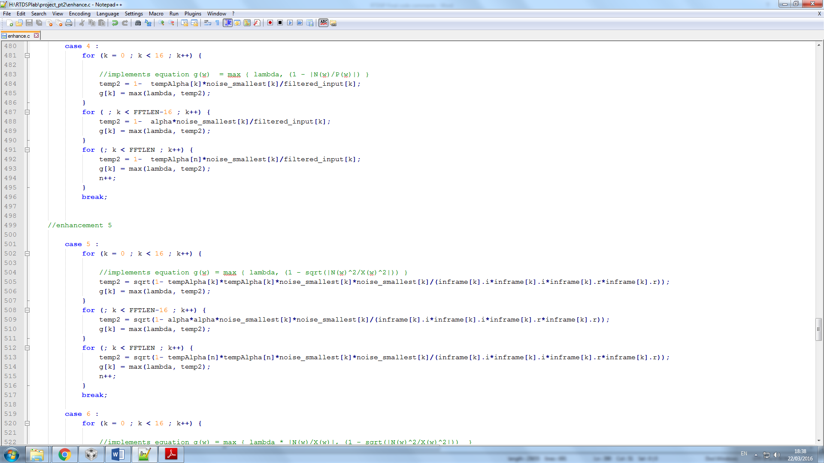

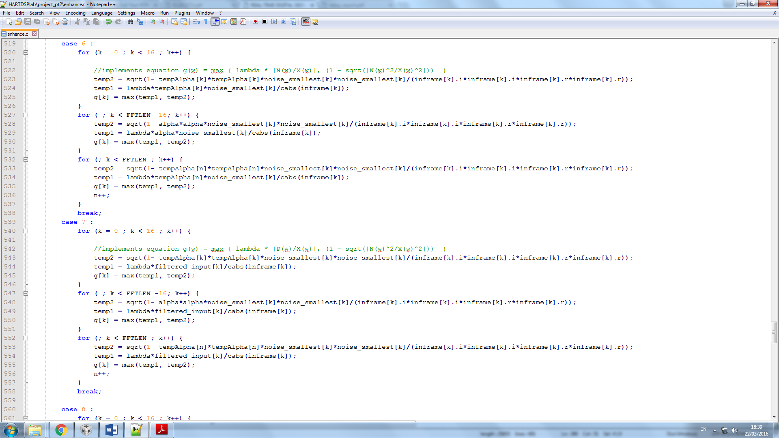

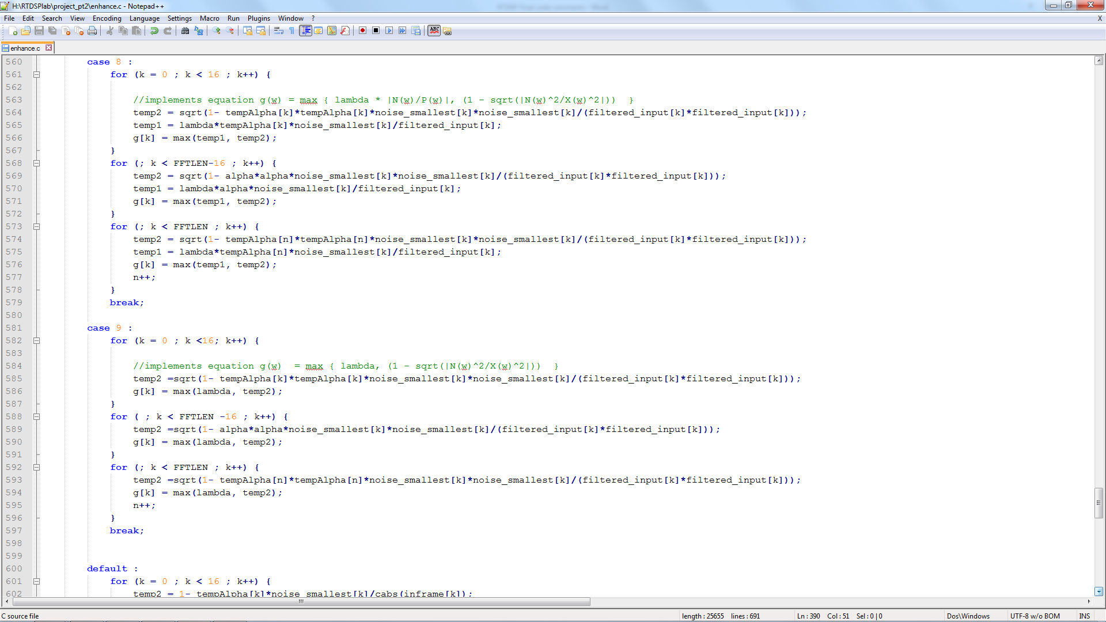

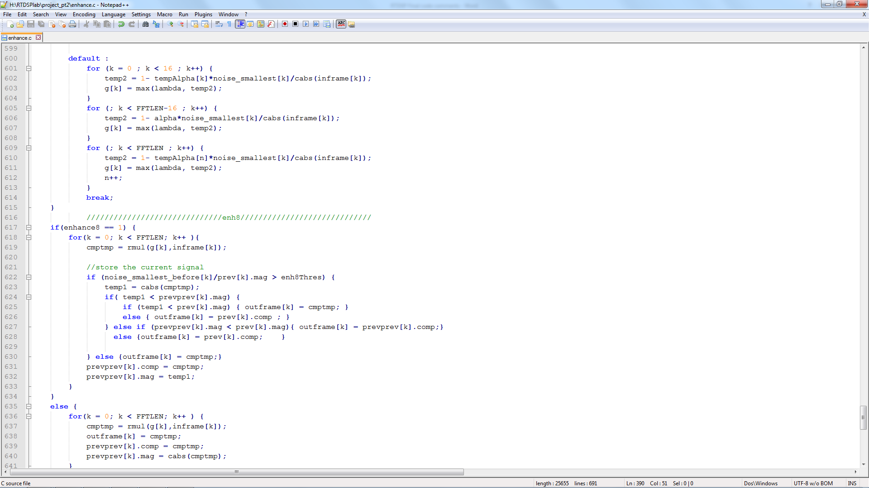

Figure 6: Code snippet implementing enhancements 4 and 5

## 4.6 Noise Level Overestimation

This enhancement aims to implement an adaptive α based on estimating SNR bin-by-bin in order to optimize the amount of noise subtraction, which should be effective in removing the associated musical noise. The relationship between α and SNR is shown in the curve in figure 7 below.



Figure 7: Graph showing relationship between value of subtraction factor vs SNR

As observed from the curve, we set α to be high when SNR is low and α to be low when SNR is high. This is reflected in our code which is shown in figure 8 below.

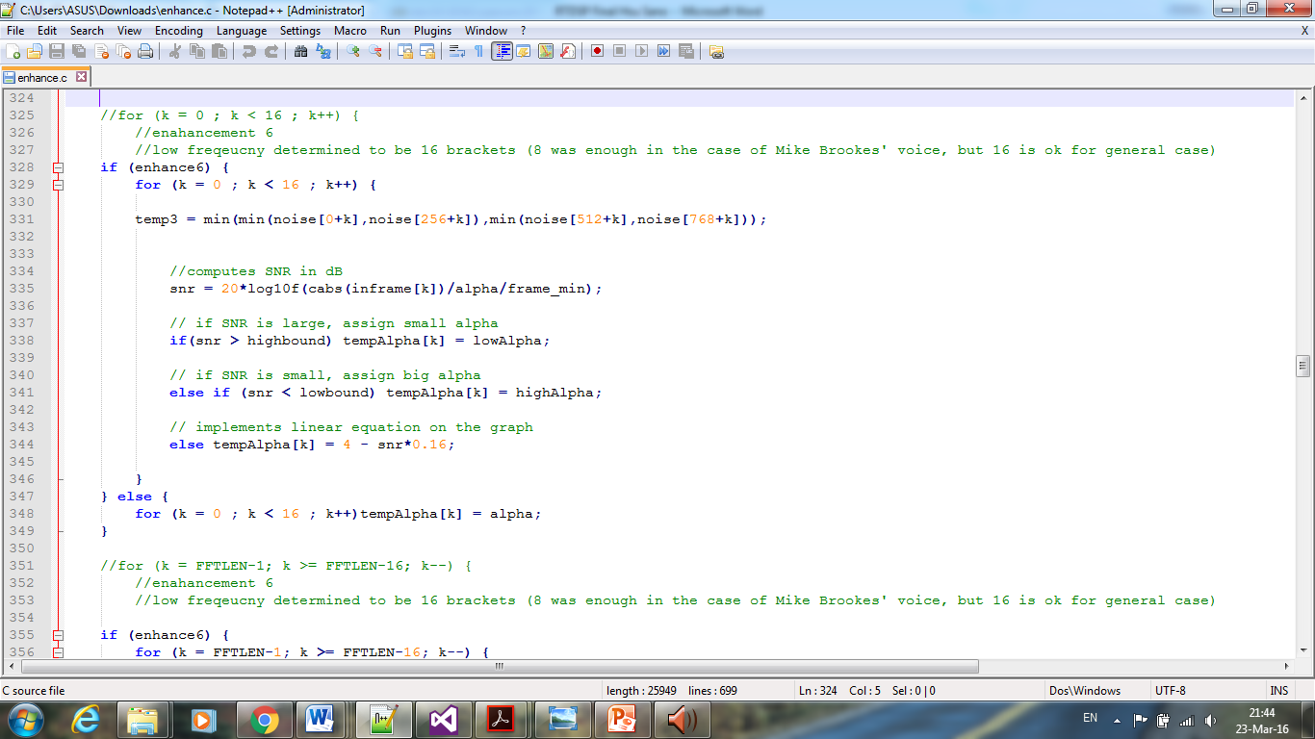

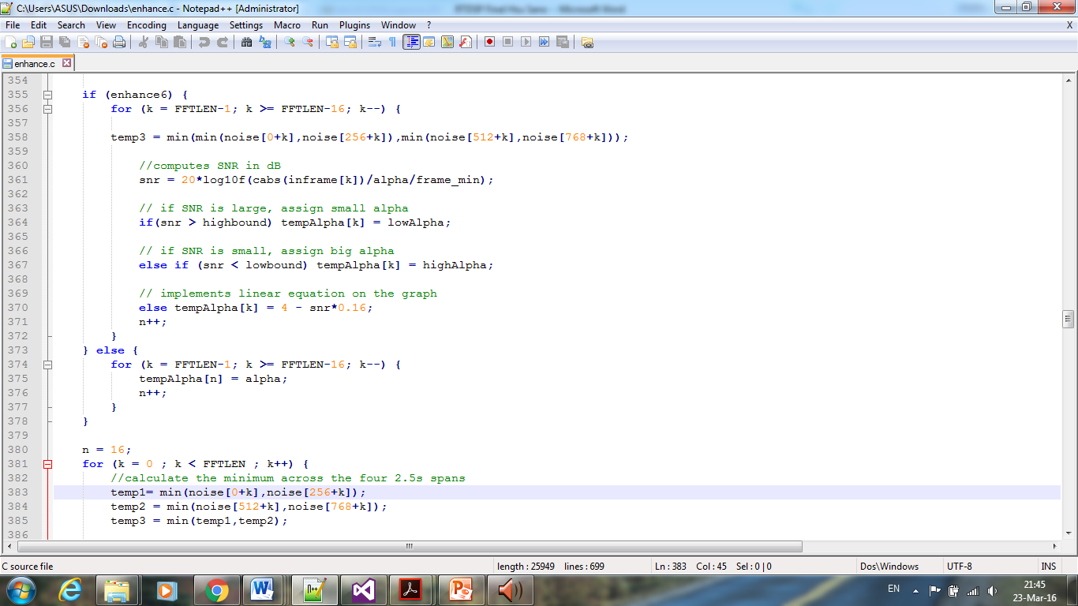

Figure 8: Code snippet implementing enhancement 6

This enhancement yielded significant improvements in speech quality and in our opinion is the best one.

## 

## 4.7 Frame Length Variation

In this enhancement, we investigated the effect of varying frame length on the speech quality. Here we tested using 128, 256 and 512 by changing the line of code shown below.

#define FFTLEN 256 /* fft length = frame length 256/8000 = 32 ms*/ //128 256 512

At frame length of 128, the quality got worse as expected, since the variance of noise is greater when frame length is shorter, meaning greater noise power. Conversely, frame length of 256 yielded better results but at frame length 512 the programme crashed (after several attempts) as it ran out of memory. Hence we concluded with using the default value of frame length 256.

## 4.8 Residual Noise Reduction

In this enhancement we attempted to reduce musical noise using residual noise reduction described in research paper [2]. The logic here is if the inverse of SNR exceeds a threshold (i.e. noise level is too high), the output Y(ω) is replaced by the minimum out of the current, previous and next frames in order to minimize the effect of the noise. After testing, we found the noise severely attenuated and the overall quality better.

Our code which implements this enhancement is shown in figure 9 below.

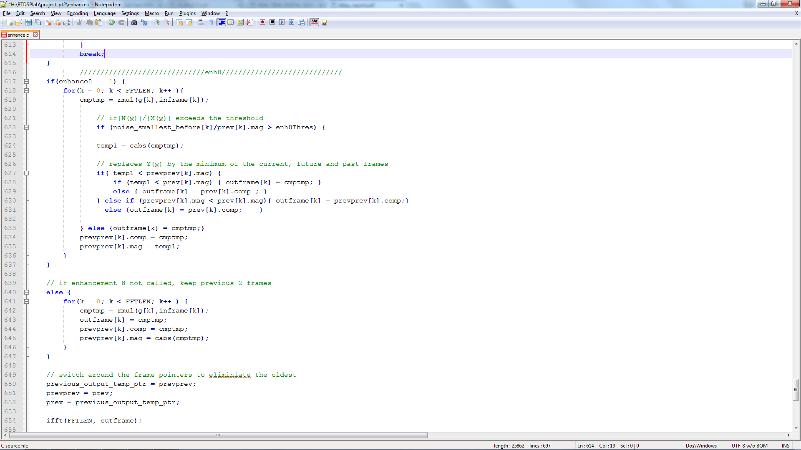

Figure 9: Code snippet implementing enhancement 8

## 4.9 Minimum Spectrum over Short Period

In this final enhancement, we decreased the period by altering the value in the line of code below in an attempt to make the system respond faster to a rise in noise level. We tested for values of 100 and 200 and found that while the quality improved, the speech appeared distorted too.

int countthres = 313;

## 4.10 Flair

In this enhancement which is beyond our coursework, we investigated into implementing the enhancement shown below in figure 10.

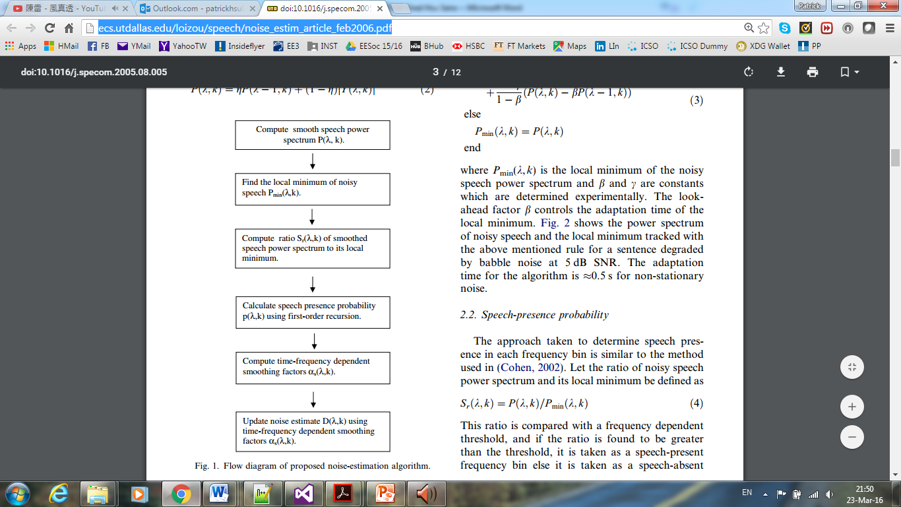

Figure 10: Block diagram of our extra enhancement

The main part of the code we have written to implement the above block diagram is shown in figure 11 below while the complete code can be found in the appendix. This enhancement was tested against the recording of phantom 4, which was extremely noisy and the most challenging of all the recordings we had. As shown in the spectrograms below in figures 12 and 12a, this enhancement was very effective in attenuating the noise and the speech spectra could be reasonably distinguished, more so than our best coursework enhancement.

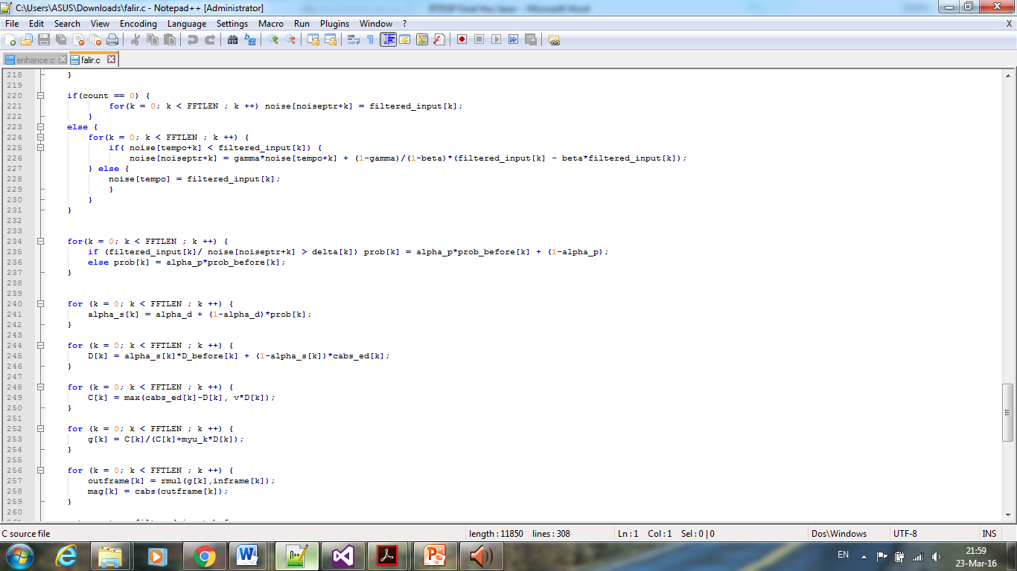

Figure 11: Main section of code for this enhancement

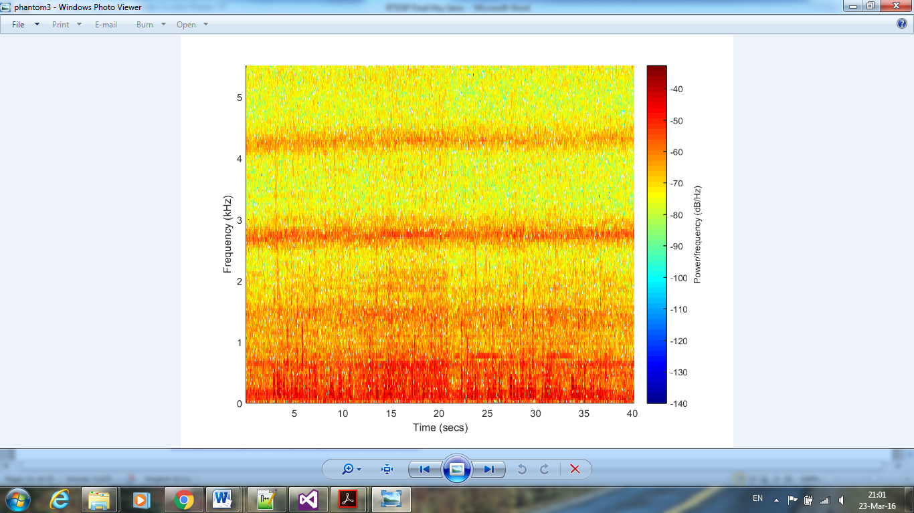

**Spectrogram of unfiltered phantom 4 recording**

Figure 12: Spectrogram of unfiltered phantom 4 recording

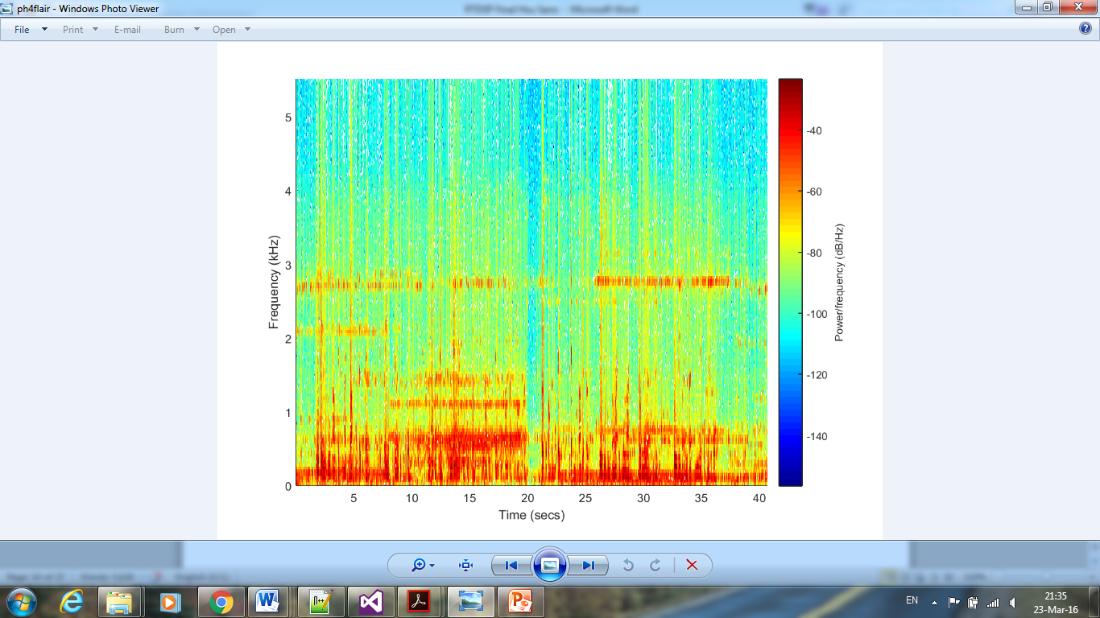

**Spectrogram of filtered phantom 4 recording using this enhancement**

Figure 12a: Spectrogram of filtered phantom 4 recording using this enhancement

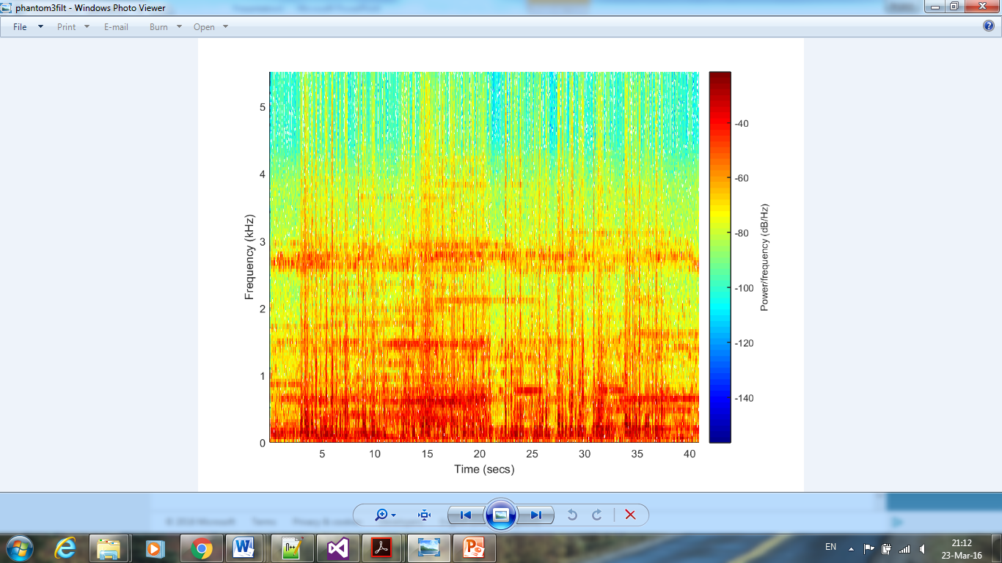

**Spectrogram of filtered phantom 4 recording using best coursework enhancement**

Figure 12b: Spectrogram of filtered phantom 4 recording using best coursework enhancement

# Conclusion and Spectrograms

After testing a mix of the 9 enhancements we made, we came to the conclusion that the following combination listed in table 2 below gave the best results, at α=2.0, τ=0.08 and λ=0.05.

|  |  |  |  |  |  |  |  |  |  |
| --- | --- | --- | --- | --- | --- | --- | --- | --- | --- |
| **Enhancement No.** | 1 | 2 | 3 | 4 | 5 | 6 | 7 | 8 | 9 |
| **Chosen? Y/N** | Y | N | Y | N | Y, default version | Y | N | N | N |

Table 2: Table showing the combination we found to give the best results

To visualize and quantify the improvement, we plotted spectrograms of the unfiltered and enhanced versions for each recording. Since phantom 4 is the most challenging recording, the spectrograms will be shown here in figures 13 and 13a, along with the clean recording for comparison in figures 14 and 14a, while others can be found in the appendix.



**Spectrogram of unfiltered phantom 4 recording**

Figure 13: Spectrogram of unfiltered phantom 4 recording



**Spectrogram of filtered phantom 4 recording**

Figure 13a: Spectrogram of filtered phantom 4 recording

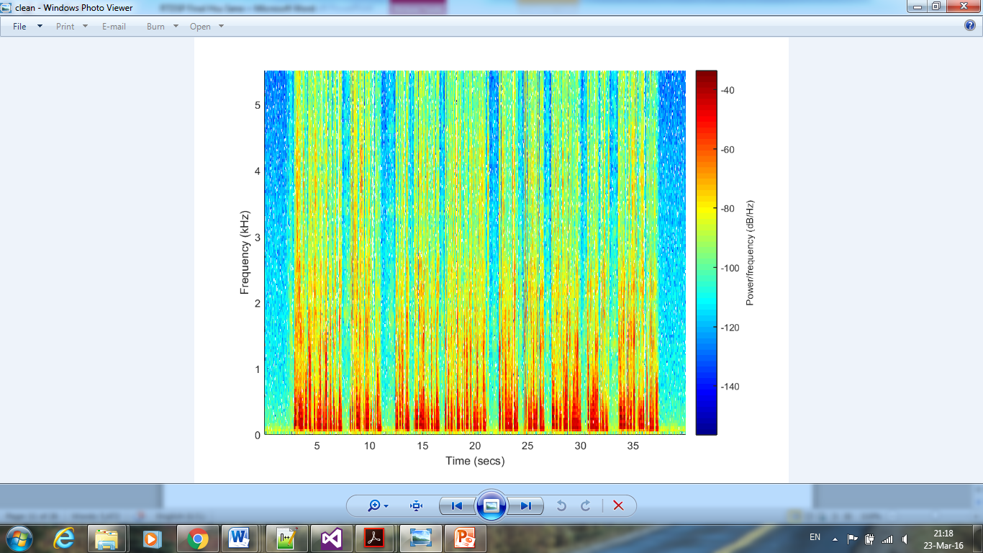

**Spectrogram of unfiltered clean recording**

Figure 14: Spectrogram of unfiltered clean recording

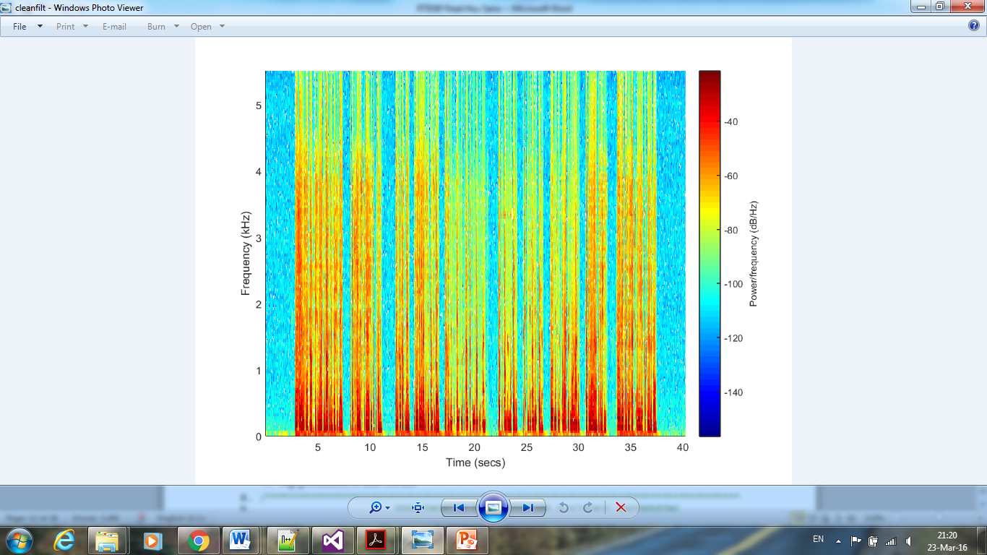

**Spectrogram of filtered clean recording**

Figure 14a: Spectrogram of filtered clean recording

As can be seen from the spectrograms above, our best enhancement was effective in improving the quality of the recordings. For the phantom 4 recording, the original version was completely submerged in noise, as the power of the noise was around the same level as the speech signal, hence making it almost inaudible. After filtering, we were able to distinguish clearly between noise, characterized by the lower powered blue and green spectrum, and speech, characterized by the higher powered red/orange/yellow spectrum. For the clean recording, the effect of our filter was to amplify the speech even more, as shown from the speech spectrum which became more red in colour.

# References

1. <https://bb.imperial.ac.uk/bbcswebdav/pid-591046-dt-content-rid-2714546_1/courses/DSS-EE3_19-15_16/project_description.pdf>

# Appendix: Full Code and Spectrograms

**Coursework Enhancements**

1. /*************************************************************************************
2. DEPARTMENT OF ELECTRICAL AND ELECTRONIC ENGINEERING
3. IMPERIAL COLLEGE LONDON
4. EE 3.19: Real Time Digital Signal Processing
5. Dr Paul Mitcheson and Daniel Harvey
6. PROJECT: Frame Processing
7. ********* ENHANCE. C **********
8. Shell for speech enhancement
9. Demonstrates overlap-add frame processing (interrupt driven) on the DSK.
10. *************************************************************************************
11. By Danny Harvey: 21 July 2006
12. Updated for use on CCS v4 Sept 2010
13. ************************************************************************************/
14. /*
15. * You should modify the code so that a speech enhancement project is built
16. * on top of this template.
17. */
18. /**************************** Pre-processor statements ******************************/
19. // library required when using calloc
20. #include <stdlib.h>
21. // Included so program can make use of DSP/BIOS configuration tool.
22. #include "dsp_bios_cfg.h"
23. /* The file dsk6713.h must be included in every program that uses the BSL. This
24. example also includes dsk6713_aic23.h because it uses the
25. AIC23 codec module (audio interface). */
26. #include "dsk6713.h"
27. #include "dsk6713_aic23.h"
28. // math library (trig functions)
29. #include <math.h>
30. /* Some functions to help with Complex algebra and FFT. */
31. #include "cmplx.h"
32. #include "fft_functions.h"
33. // Some functions to help with writing/reading the audio ports when using interrupts.
34. #include <helper_functions_ISR.h>
35. #define WINCONST 0.85185 /* 0.46/0.54 for Hamming window */
36. #define FSAMP 8000.0 /* sample frequency, ensure this matches Config for AIC */
37. //change this for one of the enhancements (7)///////////////////
38. #define FFTLEN 256 /* fft length = frame length 256/8000 = 32 ms*/ //128 256 512
39. #define NOISELEN (4*FFTLEN)
40. #define NFREQ (1+FFTLEN/2) /* number of frequency bins from a real FFT */
41. #define OVERSAMP 4 /* oversampling ratio (2 or 4) */
42. #define FRAMEINC (FFTLEN/OVERSAMP) /* Frame increment */
43. #define CIRCBUF (FFTLEN+FRAMEINC) /* length of I/O buffers */
44. #define OUTGAIN 16000.0 /* Output gain for DAC */
45. #define INGAIN (1.0/16000.0) /* Input gain for ADC */
46. #define PI 3.141592653589793
47. #define TFRAME FRAMEINC/FSAMP /* time between calculation of each frame */
48. #define max(X,Y) (X > Y ? X : Y)
49. #define min(X,Y) (X < Y ? X : Y)
50. /******************************* Global declarations ********************************/
51. /* Audio port configuration settings: these values set registers in the AIC23 audio
52. interface to configure it. See TI doc SLWS106D 3-3 to 3-10 for more info. */
53. DSK6713_AIC23_Config Config = { \
54. /**********************************************************************/
55. /* REGISTER FUNCTION SETTINGS */
56. /**********************************************************************/\
57. 0x0017, /* 0 LEFTINVOL Left line input channel volume 0dB */\
58. 0x0017, /* 1 RIGHTINVOL Right line input channel volume 0dB */\
59. 0x01f9, /* 2 LEFTHPVOL Left channel headphone volume 0dB */\
60. 0x01f9, /* 3 RIGHTHPVOL Right channel headphone volume 0dB */\
61. 0x0011, /* 4 ANAPATH Analog audio path control DAC on, Mic boost 20dB*/\
62. 0x0000, /* 5 DIGPATH Digital audio path control All Filters off */\
63. 0x0000, /* 6 DPOWERDOWN Power down control All Hardware on */\
64. 0x0043, /* 7 DIGIF Digital audio interface format 16 bit */\
65. 0x008d, /* 8 SAMPLERATE Sample rate control 8 KHZ-ensure matches FSAMP */\
66. 0x0001 /* 9 DIGACT Digital interface activation On */\
67. /**********************************************************************/
68. };
69. typedef struct enhance {
70. complex comp;
71. float mag;
73. }enhance;
74. // Codec handle:- a variable used to identify audio interface
75. DSK6713_AIC23_CodecHandle H_Codec;
76. //swithces for enhancements
77. int enhancement = 0 /* for 1 2 */, enhance3 =0, enhance45 = 0 /* for 4 5*/, enhance6 = 0, enhance8 = 0;
78. //parameters for enhancements
79. float alpha = 2, lambda = 0.05, tau = 0.02, k_enhance, *tempAlpha;
80. //hold noise for 4 2.5s(variable) sections and the minimum out of all
81. float *noise, *noise_smallest, *noise_smallest_before;
82. float *inbuffer, *outbuffer; /* Input/output circular buffers */
83. complex *inframe, *outframe; /* Input and output frames */
84. float *inwin, *outwin; /* Input and output windows */
85. //for various calculations for basic algorithm and enhancement 1 2 3
86. float *g, *filtered_input;
87. float ingain, outgain; /* ADC and DAC gains */
88. float cpufrac; /* Fraction of CPU time used */
89. //need to determine what the threshold is. for nehance 8
90. float enh8Thres = 0.9;
91. enhance * prev, * prevprev;
92. //change this for enhancement 9
93. int countthres = 313;
94. volatile int io_ptr=0; /* Input/ouput pointer for circular buffers */
95. volatile int frame_ptr=0, noise_frame_ptr = 0; /* Frame pointer */
96. //for snr enhancement 6
97. int highbound = 20;
98. int lowbound = -5;
99. float lowAlpha = 1, highAlpha = 5;
100. /******************************* Function prototypes *******************************/
101. void init_hardware(void); /* Initialize codec */
102. void init_HWI(void); /* Initialize hardware interrupts */
103. void ISR_AIC(void); /* Interrupt service routine for codec */
104. void process_frame(int count); /* Frame processing routine */
106. /********************************** Main routine ************************************/
107. void main()
108. {

//new data goes into inbuffer

1. //output to be read from is in outbuffer
2. //inwin and outwin are used to window the processed values
4. int k; // used in various for loops
5. int count25 = 0;
6. // 8000/64 * 2.5 = 313time process is called then its roughly 2.5 seconds
7. k_enhance = exp(-TFRAME/tau);
9. /* Initialize and zero fill arrays */
10. inbuffer= (float *) calloc(CIRCBUF, sizeof(float)); /* Input array */
11. outbuffer = (float *) calloc(CIRCBUF, sizeof(float)); /* Output array */
12. g= (float *) calloc(CIRCBUF, sizeof(float)); /* Output array */
13. inframe= (complex *) calloc(FFTLEN, sizeof(complex)); /* Array for processing*/
14. outframe= (complex *) calloc(FFTLEN, sizeof(complex)); /* Array for processing*/
16. //one huge noise array to store the past 10 seconds
17. noise= (float *) calloc(4*FFTLEN, sizeof(float)); /* Array for processing*/
18. noise_smallest= (float *) calloc(FFTLEN, sizeof(float)); /* Input window */
19. noise_smallest_before = (float *) calloc(FFTLEN, sizeof(float)); /* Input window */
20. inwin= (float *) calloc(FFTLEN, sizeof(float)); /* Input window */
21. outwin= (float *) calloc(FFTLEN, sizeof(float)); /* Output window */
22. filtered_input = (float *) calloc(FFTLEN, sizeof(float));

25. prev = (enhance *) calloc(FFTLEN, sizeof(enhance));
26. prevprev = (enhance *) calloc(FFTLEN, sizeof(enhance));
28. tempAlpha = (float *) calloc(2*16, sizeof(float));
29. for (k = 0; k < 2*16 ; k++)tempAlpha[k] = alpha;
31. /* initialize board and the audio port */
32. init_hardware();
34. /* initialize hardware interrupts */
35. init_HWI();
37. /* initialize algorithm constants */
39. for (k=0;k<FFTLEN;k++)
40. {
41. inwin[k] = sqrt((1.0-WINCONST*cos(PI*(2*k+1)/FFTLEN))/OVERSAMP);
42. outwin[k] = inwin[k];
43. }
44. ingain=INGAIN;
45. outgain=OUTGAIN;
47. /* main loop, wait for interrupt */
48. while(1) {
49. //count25 counts 2.5 ms as commented above
50. process_frame(count25);
51. if (++count25 >= countthres) {
52. count25 = 0;
53. //tracks which noise buffer is
54. if(++noise_frame_ptr >=4) noise_frame_ptr=0;
55. }
56. }
57. }
59. /********************************** init_hardware() *********************************/
60. void init_hardware()
61. {
62. // Initialize the board support library, must be called first
63. DSK6713_init();
65. // Start the AIC23 codec using the settings defined above in config
66. H_Codec = DSK6713_AIC23_openCodec(0, &Config);
67. /* Function below sets the number of bits in word used by MSBSP (serial port) for
68. receives from AIC23 (audio port). We are using a 32 bit packet containing two
69. 16 bit numbers hence 32BIT is set for receive */
70. MCBSP_FSETS(RCR1, RWDLEN1, 32BIT);
71. /* Configures interrupt to activate on each consecutive available 32 bits
72. from Audio port hence an interrupt is generated for each L & R sample pair */
73. MCBSP_FSETS(SPCR1, RINTM, FRM);
74. /* These commands do the same thing as above but applied to data transfers to the
75. audio port */
76. MCBSP_FSETS(XCR1, XWDLEN1, 32BIT);
77. MCBSP_FSETS(SPCR1, XINTM, FRM);
79. }
80. /********************************** init_HWI() **************************************/
81. void init_HWI(void)
82. {
83. IRQ_globalDisable(); // Globally disables interrupts
84. IRQ_nmiEnable(); // Enables the NMI interrupt (used by the debugger)
85. IRQ_map(IRQ_EVT_RINT1,4); // Maps an event to a physical interrupt
86. IRQ_enable(IRQ_EVT_RINT1); // Enables the event
87. IRQ_globalEnable(); // Globally enables interrupts
88. }
90. /******************************** process_frame() ***********************************/
91. void process_frame(int count)
92. {
93. //various temporary variables fori ntermediate steps such as when determining the minimum of noise
94. float temp1, temp2, temp3, snr=0, *noise_smallest_change_ptr;
95. enhance *previous_output_temp_ptr;
96. complex cmptmp;
97. int k, m, n = 16;
99. //to dynamically change alpha for enhancement 6
100. //float tempAlpha = alpha;
102. //noise pointer
103. int io_ptr0, noiseptr, tempo;

106. /* work out fraction of available CPU time used by algorithm */
107. //frame inc is power of 2 so something that is a power of two - 1 is ...01111111111111.... so it is basically a modulo
108. cpufrac = ((float) (io_ptr & (FRAMEINC - 1)))/FRAMEINC;
110. /* wait until io_ptr is at the start of the current frame */
111. while((io_ptr/FRAMEINC) != frame_ptr);
113. /* then increment the framecount (wrapping if required) */
114. if (++frame_ptr >= (CIRCBUF/FRAMEINC)) frame_ptr=0;
116. /* save a pointer to the position in the I/O buffers (inbuffer/outbuffer) where the
117. data should be read (inbuffer) and saved (outbuffer) for the purpose of processing */
118. io_ptr0=frame_ptr * FRAMEINC;
120. /* copy input data from inbuffer into inframe (starting from the pointer position) */
122. m=io_ptr0;
123. for (k=0;k<FFTLEN;k++)
124. {
125. inframe[k].r = inbuffer[m] * inwin[k]; //mult by filter so you need to copy the whole inbuffer everytime
126. inframe[k].i = 0;
127. if (++m >= CIRCBUF) m = 0;
128. }
130. /************************* DO PROCESSING OF FRAME HERE **************************/
131. fft(FFTLEN, inframe);
132. //to determine the exact location of current noise to update in the huge array
133. noiseptr = FFTLEN * noise_frame_ptr;
134. //just to not to lose track of noiseptr, assign it with another variable
135. tempo = noiseptr;
137. //for enhancements 1 2 and most naive algorithm
138. if(count == 0) {
139. for(k = 0; k < FFTLEN ; k ++) {
140. noise[tempo] = cabs(inframe[k]);
141. //preincrement check
142. if (++tempo >= NOISELEN) tempo = 0;
143. }
145. }
146. else {
147. //minimum noise for the current 2.5 second bracket
148. for(k = 0; k < FFTLEN ; k ++)noise[tempo] = min(noise[tempo],cabs(inframe[k]));
149. }
151. if(enhancement == 0) { //no enhancement
152. //so the other algorithms work regardless of having opt 1 or 2 or not
153. for(k = 0; k < FFTLEN ; k ++) filtered_input[k] = cabs(inframe[k]);
154. }
156. // enhancement 1
157. else if (enhancement == 1) {
158. for(k = 0; k < FFTLEN ; k ++)
160. // implements the equation P_t(w) = (1-k)*|X(w)| + (k) * P_t-1(w)
161. filtered_input[k] = cabs(inframe[k])*(1-k_enhance)+k_enhance*filtered_input[k];
162. noise[tempo] = filtered_input[k];
163. }
165. // enhancement 2
166. else if (enhancement == 2) {
167. for(k = 0; k < FFTLEN ; k ++)
169. // implements the equation P_t(w) = SQRT[ (k) * (P_t-1(w))^2 +(1-k)*|X(w)|^2 ]
170. filtered_input[k] = sqrt((inframe[k].i*inframe[k].i*inframe[k].r*inframe[k].r)*(1-k_enhance)+k_enhance*filtered_input[k]*filtered_input[k]);
171. noise[tempo] = filtered_input[k];
172. }
174. tempo = noiseptr;
175. //for enhancement 8
176. noise_smallest_change_ptr = noise_smallest_before;
177. noise_smallest_before = noise_smallest;
178. noise_smallest = noise_smallest_change_ptr;
180. //for (k = 0 ; k < 16 ; k++) {
181. //enahancement 6
182. //low freqeucny determined to be 16 brackets (8 was enough in the case of Mike Brookes' voice, but 16 is ok for general case)
183. if (enhance6) {
184. for (k = 0 ; k < 16 ; k++) {
185. temp3 = min(min(noise[0+k],noise[256+k]),min(noise[512+k],noise[768+k]));

188. //computes SNR in dB
189. snr = 20*log10f(cabs(inframe[k])/alpha/frame_min);
191. // if SNR is large, assign small alpha
192. if(snr > highbound) tempAlpha[k] = lowAlpha;
194. // if SNR is small, assign big alpha
195. else if (snr < lowbound) tempAlpha[k] = highAlpha;
197. // implements linear equation on the graph
198. else tempAlpha[k] = 4 - snr*0.16;
200. }
201. } else {
202. for (k = 0 ; k < 16 ; k++)tempAlpha[k] = alpha;
203. }
205. //for (k = FFTLEN-1; k >= FFTLEN-16; k--) {
206. //enahancement 6
207. //low freqeucny determined to be 16 brackets (8 was enough in the case of Mike Brookes' voice, but 16 is ok for general case)
209. if (enhance6) {
210. for (k = FFTLEN-1; k >= FFTLEN-16; k--) {
211. temp3 = min(min(noise[0+k],noise[256+k]),min(noise[512+k],noise[768+k]));
213. //computes SNR in dB
214. snr = 20*log10f(cabs(inframe[k])/alpha/frame_min);
216. // if SNR is large, assign small alpha
217. if(snr > highbound) tempAlpha[k] = lowAlpha;
219. // if SNR is small, assign big alpha
220. else if (snr < lowbound) tempAlpha[k] = highAlpha;
222. // implements linear equation on the graph
223. else tempAlpha[k] = 4 - snr*0.16;
224. n++;
225. }
226. } else {
227. for (k = FFTLEN-1; k >= FFTLEN-16; k--) {
228. tempAlpha[n] = alpha;
229. n++;
230. }
231. }
233. n = 16;
234. for (k = 0 ; k < FFTLEN ; k++) {
235. //calculate the minimum across the four 2.5s spans
236. temp1= min(noise[0+k],noise[256+k]);
237. temp2 = min(noise[512+k],noise[768+k]);
238. temp3 = min(temp1,temp2);

241. //filter the noise too, if wanted
242. if(enhance3 != 1) noise_smallest[k] = temp3;
244. // P_N_t(w) = (1-k) * |X(w)| + (k) * P_N_t-1(w)
245. else noise_smallest[k] = temp3*(1-k_enhance)+k_enhance*noise_smallest_before[k];
247. }
249. switch (enhance45) {
250. // case 0 to 4 for enhancement 4, 1 to 5
251. // case 5 to 9 for enhancement 5, 1 to 5
252. // default case is enhancement 4-1
253. case 0 :
254. for (k = 0 ; k < 16 ; k++) {
256. //implements equation g(w) = max { lambda, (1 - |N(w)/X(w)|) }
257. temp2 = 1- tempAlpha[k]*noise_smallest[k]/cabs(inframe[k]);
258. g[k] = max(lambda, temp2);
259. }
260. for (; k < FFTLEN-16 ; k++) {
261. temp2 = 1- alpha*noise_smallest[k]/cabs(inframe[k]);
262. g[k] = max(lambda, temp2);
263. }
264. for (; k < FFTLEN ; k++) {
265. temp2 = 1-tempAlpha[n]*noise_smallest[k]/cabs(inframe[k]);
266. g[k] = max(lambda, temp2);
267. n++;
268. }
269. break;
271. case 1 :
272. for (k = 0 ; k < 16 ; k++) {
274. //implements equation g(w) = max { lambda * |N(w)/X(w)|, (1 - |N(w)/X(w)|) }
275. temp2 = 1- tempAlpha[k]*noise_smallest[k]/cabs(inframe[k]);
276. temp1 = lambda*tempAlpha[k]*noise_smallest[k]/cabs(inframe[k]);
277. g[k] = max(temp1, temp2);
278. }
279. for ( ; k < FFTLEN-16 ; k++) {
281. temp2 = 1- alpha*noise_smallest[k]/cabs(inframe[k]);
282. temp1 = lambda*alpha*noise_smallest[k]/cabs(inframe[k]);
283. g[k] = max(temp1, temp2);
284. }
285. for (; k < FFTLEN ; k++) {
286. temp2 = 1- tempAlpha[n]*noise_smallest[k]/cabs(inframe[k]);
287. temp1 = lambda*tempAlpha[n]*noise_smallest[k]/cabs(inframe[k]);
288. g[k] = max(temp1, temp2);
289. n++;
290. }
291. break;
293. case 2 :
294. for (k = 0 ; k <16; k++) {
296. //implements equation g(w) = max { lambda * |P(w)/X(w)|, (1 - |N(w)/X(w)|) }
297. temp2 = 1- tempAlpha[k]*noise_smallest[k]/cabs(inframe[k]);
298. temp1 = lambda*filtered_input[k]/cabs(inframe[k]);
299. g[k] = max(temp1, temp2);
300. }
301. for ( ; k < FFTLEN -16; k++) {
302. temp2 = 1- alpha*noise_smallest[k]/cabs(inframe[k]);
303. temp1 = lambda*filtered_input[k]/cabs(inframe[k]);
304. g[k] = max(temp1, temp2);
305. }
306. for ( ; k < FFTLEN ; k++) {
307. temp2 = 1- tempAlpha[n]*noise_smallest[k]/cabs(inframe[k]);
308. temp1 = lambda*filtered_input[k]/cabs(inframe[k]);
309. g[k] = max(temp1, temp2);
310. n++;
311. }
312. break;
314. case 3 :
315. for (k = 0 ; k < 16; k++) {
317. //implements equation g(w) = max { lambda * |N(w)/P(w)|, (1 - |N(w)/P(w)|) }
318. temp2 = 1- tempAlpha[k]*noise_smallest[k]/filtered_input[k];
319. temp1 = lambda*tempAlpha[k]*noise_smallest[k]/filtered_input[k];
320. g[k] = max(temp1, temp2);
321. }
322. for (; k < FFTLEN-16 ; k++) {
323. temp2 = 1- alpha*noise_smallest[k]/filtered_input[k];
324. temp1 = lambda*alpha*noise_smallest[k]/filtered_input[k];
325. g[k] = max(temp1, temp2);
326. }
327. for (; k < FFTLEN ; k++) {
328. temp2 = 1- tempAlpha[n]*noise_smallest[k]/filtered_input[k];
329. temp1 = lambda*tempAlpha[n]*noise_smallest[k]/filtered_input[k];
330. g[k] = max(temp1, temp2);
331. n++;
332. }
333. break;
335. case 4 :
336. for (k = 0 ; k < 16 ; k++) {
338. //implements equation g(w) = max { lambda, (1 - |N(w)/P(w)|) }
339. temp2 = 1- tempAlpha[k]*noise_smallest[k]/filtered_input[k];
340. g[k] = max(lambda, temp2);
341. }
342. for ( ; k < FFTLEN-16 ; k++) {
343. temp2 = 1- alpha*noise_smallest[k]/filtered_input[k];
344. g[k] = max(lambda, temp2);
345. }
346. for (; k < FFTLEN ; k++) {
347. temp2 = 1- tempAlpha[n]*noise_smallest[k]/filtered_input[k];
348. g[k] = max(lambda, temp2);
349. n++;
350. }
351. break;

354. //enhancement 5
355. case 5 :
356. for (k = 0 ; k < 16 ; k++) {
358. //implements equation g(w) = max { lambda, (1 - sqrt(|N(w)^2/X(w)^2|)) }
359. temp2 = sqrt(1- tempAlpha[k]*tempAlpha[k]*noise_smallest[k]*noise_smallest[k]/(inframe[k].i*inframe[k].i*inframe[k].r*inframe[k].r));
360. g[k] = max(lambda, temp2);
361. }
362. for (; k < FFTLEN-16 ; k++) {
363. temp2 = sqrt(1- alpha*alpha*noise_smallest[k]*noise_smallest[k]/(inframe[k].i*inframe[k].i*inframe[k].r*inframe[k].r));
364. g[k] = max(lambda, temp2);
365. }
366. for (; k < FFTLEN ; k++) {
367. temp2 = sqrt(1- tempAlpha[n]*tempAlpha[n]*noise_smallest[k]*noise_smallest[k]/(inframe[k].i*inframe[k].i*inframe[k].r*inframe[k].r));
368. g[k] = max(lambda, temp2);
369. n++;
370. }
371. break;
373. case 6 :
374. for (k = 0 ; k < 16 ; k++) {
376. //implements equation g(w) = max { lambda * |N(w)/X(w)|, (1 - sqrt(|N(w)^2/X(w)^2|)) }
377. temp2 = sqrt(1- tempAlpha[k]*tempAlpha[k]*noise_smallest[k]*noise_smallest[k]/(inframe[k].i*inframe[k].i*inframe[k].r*inframe[k].r));
378. temp1 = lambda*tempAlpha[k]*noise_smallest[k]/cabs(inframe[k]);
379. g[k] = max(temp1, temp2);
380. }
381. for ( ; k < FFTLEN -16; k++) {
382. temp2 = sqrt(1- alpha*alpha*noise_smallest[k]*noise_smallest[k]/(inframe[k].i*inframe[k].i*inframe[k].r*inframe[k].r));
383. temp1 = lambda*alpha*noise_smallest[k]/cabs(inframe[k]);
384. g[k] = max(temp1, temp2);
385. }
386. for (; k < FFTLEN ; k++) {
387. temp2 = sqrt(1- tempAlpha[n]*tempAlpha[n]*noise_smallest[k]*noise_smallest[k]/(inframe[k].i*inframe[k].i*inframe[k].r*inframe[k].r));
388. temp1 = lambda*tempAlpha[n]*noise_smallest[k]/cabs(inframe[k]);
389. g[k] = max(temp1, temp2);
390. n++;
391. }
392. break;
393. case 7 :
394. for (k = 0 ; k < 16 ; k++) {
396. //implements equation g(w) = max { lambda * |P(w)/X(w)|, (1 - sqrt(|N(w)^2/X(w)^2|)) }
397. temp2 = sqrt(1- tempAlpha[k]*tempAlpha[k]*noise_smallest[k]*noise_smallest[k]/(inframe[k].i*inframe[k].i*inframe[k].r*inframe[k].r));
398. temp1 = lambda*filtered_input[k]/cabs(inframe[k]);
399. g[k] = max(temp1, temp2);
400. }
401. for ( ; k < FFTLEN -16; k++) {
402. temp2 = sqrt(1- alpha*alpha*noise_smallest[k]*noise_smallest[k]/(inframe[k].i*inframe[k].i*inframe[k].r*inframe[k].r));
403. temp1 = lambda*filtered_input[k]/cabs(inframe[k]);
404. g[k] = max(temp1, temp2);
405. }
406. for (; k < FFTLEN ; k++) {
407. temp2 = sqrt(1- tempAlpha[n]*tempAlpha[n]*noise_smallest[k]*noise_smallest[k]/(inframe[k].i*inframe[k].i*inframe[k].r*inframe[k].r));
408. temp1 = lambda*filtered_input[k]/cabs(inframe[k]);
409. g[k] = max(temp1, temp2);
410. n++;
411. }
412. break;
414. case 8 :
415. for (k = 0 ; k < 16 ; k++) {
417. //implements equation g(w) = max { lambda * |N(w)/P(w)|, (1 - sqrt(|N(w)^2/X(w)^2|)) }
418. temp2 = sqrt(1- tempAlpha[k]*tempAlpha[k]*noise_smallest[k]*noise_smallest[k]/(filtered_input[k]*filtered_input[k]));
419. temp1 = lambda*tempAlpha[k]*noise_smallest[k]/filtered_input[k];
420. g[k] = max(temp1, temp2);
421. }
422. for (; k < FFTLEN-16 ; k++) {
423. temp2 = sqrt(1- alpha*alpha*noise_smallest[k]*noise_smallest[k]/(filtered_input[k]*filtered_input[k]));
424. temp1 = lambda*alpha*noise_smallest[k]/filtered_input[k];
425. g[k] = max(temp1, temp2);
426. }
427. for (; k < FFTLEN ; k++) {
428. temp2 = sqrt(1- tempAlpha[n]*tempAlpha[n]*noise_smallest[k]*noise_smallest[k]/(filtered_input[k]*filtered_input[k]));
429. temp1 = lambda*tempAlpha[n]*noise_smallest[k]/filtered_input[k];
430. g[k] = max(temp1, temp2);
431. n++;
432. }
433. break;
435. case 9 :
436. for (k = 0 ; k <16; k++) {
438. //implements equation g(w) = max { lambda, (1 - sqrt(|N(w)^2/X(w)^2|)) }
439. temp2 =sqrt(1- tempAlpha[k]*tempAlpha[k]*noise_smallest[k]*noise_smallest[k]/(filtered_input[k]*filtered_input[k]));
440. g[k] = max(lambda, temp2);
441. }
442. for ( ; k < FFTLEN -16 ; k++) {
443. temp2 =sqrt(1- alpha*alpha*noise_smallest[k]*noise_smallest[k]/(filtered_input[k]*filtered_input[k]));
444. g[k] = max(lambda, temp2);
445. }
446. for (; k < FFTLEN ; k++) {
447. temp2 =sqrt(1- tempAlpha[n]*tempAlpha[n]*noise_smallest[k]*noise_smallest[k]/(filtered_input[k]*filtered_input[k]));
448. g[k] = max(lambda, temp2);
449. n++;
450. }
451. break;

454. default :
455. for (k = 0 ; k < 16 ; k++) {
456. temp2 = 1- tempAlpha[k]*noise_smallest[k]/cabs(inframe[k]);
457. g[k] = max(lambda, temp2);
458. }
459. for (; k < FFTLEN-16 ; k++) {
460. temp2 = 1- alpha*noise_smallest[k]/cabs(inframe[k]);
461. g[k] = max(lambda, temp2);
462. }
463. for (; k < FFTLEN ; k++) {
464. temp2 = 1- tempAlpha[n]*noise_smallest[k]/cabs(inframe[k]);
465. g[k] = max(lambda, temp2);
466. n++;
467. }
468. break;
469. }
470. //////////////////////////////enh8/////////////////////////////
471. if(enhance8 == 1) {
472. for(k = 0; k < FFTLEN; k++ ){
473. cmptmp = rmul(g[k],inframe[k]);
475. // if|N(w)|/|X(w)| exceeds the threshold
476. if (noise_smallest_before[k]/prev[k].mag > enh8Thres) {
478. temp1 = cabs(cmptmp);
480. // replaces Y(w) by the minimum of the current, future and past frames
481. if( temp1 < prevprev[k].mag) {
482. if (temp1 < prev[k].mag) { outframe[k] = cmptmp; }
483. else { outframe[k] = prev[k].comp ; }
484. } else if (prevprev[k].mag < prev[k].mag){ outframe[k] = prevprev[k].comp;}
485. else {outframe[k] = prev[k].comp; }
487. } else {outframe[k] = cmptmp;}
488. prevprev[k].comp = cmptmp;
489. prevprev[k].mag = temp1;
490. }
491. }
493. // if enhancement 8 not called, keep previous 2 frames
494. else {
495. for(k = 0; k < FFTLEN; k++ ) {
496. cmptmp = rmul(g[k],inframe[k]);
497. outframe[k] = cmptmp;
498. prevprev[k].comp = cmptmp;
499. prevprev[k].mag = cabs(cmptmp);
500. }
501. }
502. // switch around the frame pointers to eliminiate the oldest
503. previous_output_temp_ptr = prevprev;
504. prevprev = prev;
505. prev = previous_output_temp_ptr;
507. ifft(FFTLEN, outframe);
509. //8000/64 * 2.5 = 313time process is called then its roughly 2.5 seconds
510. //8000/64 = 125
512. /********************************************************************************/
514. /* multiply outframe by output window and overlap-add into output buffer */
516. m=io_ptr0;
518. for (k=0;k<(FFTLEN-FRAMEINC);k++)
519. { /* this loop adds into outbuffer */
520. outbuffer[m] = outbuffer[m]+outframe[k].r*outwin[k];
521. if (++m >= CIRCBUF) m = 0; /* wrap if required */
522. }
523. for (;k<FFTLEN;k++)
524. {
525. outbuffer[m] = outwin[k] * outframe[k].r; /* this loop over-writes outbuffer */
526. m++;
527. }
529. }
530. /*************************** INTERRUPT SERVICE ROUTINE *****************************/
531. // Map this to the appropriate interrupt in the CDB file
533. void ISR_AIC(void)
534. {
535. short sample;
536. /* Read and write the ADC and DAC using inbuffer and outbuffer */
538. sample = mono_read_16Bit();
539. inbuffer[io_ptr] = ((float)sample)*ingain;
540. /* write new output data */
541. mono_write_16Bit((int)(outbuffer[io_ptr]*outgain));
543. /* update io_ptr and check for buffer wraparound */
545. if (++io_ptr >= CIRCBUF) io_ptr=0;
546. }
547. /************************************************************************************/

**FLAIR ENHANCEMENT**

/**************************** Pre-processor statements ******************************/

#include <stdlib.h>

#include "dsp_bios_cfg.h"

#include "dsk6713.h"

#include "dsk6713_aic23.h"

#include <math.h>

#include "cmplx.h"

#include "fft_functions.h"

#include <helper_functions_ISR.h>

#define WINCONST 0.85185 /* 0.46/0.54 for Hamming window */

#define FSAMP 8000.0 /* sample frequency, ensure this matches Config for AIC */

#define FFTLEN 256 /* fft length = frame length 256/8000 = 32 ms*/ //128 256 512

#define NOISELEN (4*FFTLEN)

#define NFREQ (1+FFTLEN/2) /* number of frequency bins from a real FFT */

#define OVERSAMP 4 /* oversampling ratio (2 or 4) */

#define FRAMEINC (FFTLEN/OVERSAMP) /* Frame increment */

#define CIRCBUF (FFTLEN+FRAMEINC) /* length of I/O buffers */

#define OUTGAIN 16000.0 /* Output gain for DAC */

#define INGAIN (1.0/16000.0) /* Input gain for ADC */

#define PI 3.141592653589793

#define TFRAME FRAMEINC/FSAMP /* time between calculation of each frame */

#define max(X,Y) (X > Y ? X : Y)

#define min(X,Y) (X < Y ? X : Y)

/******************************* Global declarations ********************************/

/* Audio port configuration settings: these values set registers in the AIC23 audio

interface to configure it. See TI doc SLWS106D 3-3 to 3-10 for more info. */

DSK6713_AIC23_Config Config = { \

/**********************************************************************/

/* REGISTER FUNCTION SETTINGS */

/**********************************************************************/\

0x0017, /* 0 LEFTINVOL Left line input channel volume 0dB */\

0x0017, /* 1 RIGHTINVOL Right line input channel volume 0dB */\

0x01f9, /* 2 LEFTHPVOL Left channel headphone volume 0dB */\

0x01f9, /* 3 RIGHTHPVOL Right channel headphone volume 0dB */\

0x0011, /* 4 ANAPATH Analog audio path control DAC on, Mic boost 20dB*/\

0x0000, /* 5 DIGPATH Digital audio path control All Filters off */\

0x0000, /* 6 DPOWERDOWN Power down control All Hardware on */\

0x0043, /* 7 DIGIF Digital audio interface format 16 bit */\

0x008d, /* 8 SAMPLERATE Sample rate control 8 KHZ-ensure matches FSAMP */\

0x0001 /* 9 DIGACT Digital interface activation On */\

/**********************************************************************/

};

// Codec handle:- a variable used to identify audio interface

DSK6713_AIC23_CodecHandle H_Codec;

float tau = 0.02, k_enhance;

float *inbuffer, *outbuffer; /* Input/output circular buffers */

complex *inframe, *outframe; /* Input and output frames */

float *inwin, *outwin; /* Input and output windows */

float *g, *filtered_input;

float ingain, outgain; /* ADC and DAC gains */

float cpufrac;

float *noise, *delta, *alpha_s, *D, *C, *D_before, *cabs_ed, *filtered_input_before, *prob, *prob_before;

float alpha_d=0.85, alpha_p=0.2, beta=0.8, myu_k=5, gamma=0.998, v = 0.001;

int countthres = 313;

volatile int io_ptr=0; /* Input/ouput pointer for circular buffers */

volatile int frame_ptr=0, noise_frame_ptr = 0; /* Frame pointer */

/******************************* Function prototypes *******************************/

void init_hardware(void); /* Initialize codec */

void init_HWI(void); /* Initialize hardware interrupts */

void ISR_AIC(void); /* Interrupt service routine for codec */

void process_frame(int count); /* Frame processing routine */

/********************************** Main routine ************************************/

void main()

{

int k; // used in various for loops

int count25 = 0; // 8000/64 * 2.5 = 313time process is called then its roughly 2.5 seconds

k_enhance =0.7; // exp(-TFRAME/tau);

noise = (float *) calloc(4*FFTLEN, sizeof(float));

inbuffer = (float *) calloc(CIRCBUF, sizeof(float)); /* Input array */

outbuffer = (float *) calloc(CIRCBUF, sizeof(float)); /* Output array */

g = (float *) calloc(CIRCBUF, sizeof(float)); /* Output array */

inframe = (complex *) calloc(FFTLEN, sizeof(complex)); /* Array for processing*/

outframe = (complex *) calloc(FFTLEN, sizeof(complex)); /* Array for processing*/

delta = (float *) calloc(FFTLEN, sizeof(float)); /* Input window */

alpha_s = (float *) calloc(FFTLEN, sizeof(float)); /* Input window */

D = (float *) calloc(FFTLEN, sizeof(float)); /* Input window */

C = (float *) calloc(FFTLEN, sizeof(float)); /* Input window */

D_before = (float *) calloc(FFTLEN, sizeof(float)); /* Input window */

inwin = (float *) calloc(FFTLEN, sizeof(float)); /* Input window */

outwin = (float *) calloc(FFTLEN, sizeof(float)); /* Output window */

filtered_input = (float *) calloc(FFTLEN, sizeof(float));

cabs_ed = (float *) calloc(FFTLEN, sizeof(float));

filtered_input_before = (float *) calloc(FFTLEN, sizeof(float));

prob = (float *) calloc(FFTLEN, sizeof(float));

prob_before = (float *) calloc(FFTLEN, sizeof(float));

for (k=0;k<96; k++) delta[k] = 2 ;

for (; k < FFTLEN/2 ; k++) delta[k] = 5;

for(k = FFTLEN-1; k>FFTLEN-1-96; k--) delta[k] = 2;

for(; k >= FFTLEN/2 ; k--) delta[k]=5;

init_hardware();

init_HWI();

for (k=0;k<FFTLEN;k++)

{

inwin[k] = sqrt((1.0-WINCONST*cos(PI*(2*k+1)/FFTLEN))/OVERSAMP);

outwin[k] = inwin[k];

}

ingain=INGAIN;

outgain=OUTGAIN;

/* main loop, wait for interrupt */

while(1) {

//count25 counts 2.5 ms as commented above

process_frame(count25);

if (++count25 >= countthres) {

count25 = 0;

//tracks which noise buffer is

if(++noise_frame_ptr >=4) noise_frame_ptr=0;

}

}

}

/********************************** init_hardware() *********************************/

void init_hardware()

{

// Initialize the board support library, must be called first

DSK6713_init();

// Start the AIC23 codec using the settings defined above in config

H_Codec = DSK6713_AIC23_openCodec(0, &Config);

/* Function below sets the number of bits in word used by MSBSP (serial port) for

receives from AIC23 (audio port). We are using a 32 bit packet containing two

16 bit numbers hence 32BIT is set for receive */

MCBSP_FSETS(RCR1, RWDLEN1, 32BIT);

/* Configures interrupt to activate on each consecutive available 32 bits

from Audio port hence an interrupt is generated for each L & R sample pair */

MCBSP_FSETS(SPCR1, RINTM, FRM);

/* These commands do the same thing as above but applied to data transfers to the

audio port */

MCBSP_FSETS(XCR1, XWDLEN1, 32BIT);

MCBSP_FSETS(SPCR1, XINTM, FRM);

}

/********************************** init_HWI() **************************************/

void init_HWI(void)

{

IRQ_globalDisable(); // Globally disables interrupts

IRQ_nmiEnable(); // Enables the NMI interrupt (used by the debugger)

IRQ_map(IRQ_EVT_RINT1,4); // Maps an event to a physical interrupt

IRQ_enable(IRQ_EVT_RINT1); // Enables the event

IRQ_globalEnable(); // Globally enables interrupts

}

/******************************** process_frame() ***********************************/

void process_frame(int count)

{

//various temporary variables fori ntermediate steps such as when determining the minimum of noise

float *p_temp_ptr, temp1;

float mag[FFTLEN];

int k, tempo, noiseptr;

//noise pointer

int io_ptr0, m;

/* work out fraction of available CPU time used by algorithm */

//frame inc is power of 2 so something that is a power of two - 1 is ...01111111111111.... so it is basically a modulo

cpufrac = ((float) (io_ptr & (FRAMEINC - 1)))/FRAMEINC;

/* wait until io_ptr is at the start of the current frame */

while((io_ptr/FRAMEINC) != frame_ptr);

/* then increment the framecount (wrapping if required) */

if (++frame_ptr >= (CIRCBUF/FRAMEINC)) frame_ptr=0;

/* save a pointer to the position in the I/O buffers (inbuffer/outbuffer) where the

data should be read (inbuffer) and saved (outbuffer) for the purpose of processing */

io_ptr0=frame_ptr * FRAMEINC;

/* copy input data from inbuffer into inframe (starting from the pointer position) */

m=io_ptr0;

for (k=0;k<FFTLEN;k++)

{

inframe[k].r = inbuffer[m] * inwin[k]; //mult by filter so you need to copy the whole inbuffer everytime

inframe[k].i = 0;

if (++m >= CIRCBUF) m = 0;

}

/************************* DO PROCESSING OF FRAME HERE **************************/

fft(FFTLEN, inframe);

noiseptr = FFTLEN * noise_frame_ptr;

if(noise_frame_ptr ==0) tempo = 3*FFTLEN;

else tempo = (noise_frame_ptr-1)*FFTLEN;

for(k = 0; k < FFTLEN ; k ++) {

temp1 = cabs(inframe[k]);

cabs_ed[k] = temp1*temp1;

filtered_input[k] = filtered_input_before[k]*k_enhance + (1-k_enhance)*cabs_ed[k];

}

if(count == 0) {

for(k = 0; k < FFTLEN ; k ++) noise[noiseptr+k] = filtered_input[k];

}

else {

for(k = 0; k < FFTLEN ; k ++) {

if( noise[tempo+k] < filtered_input[k]) {

noise[noiseptr+k] = gamma*noise[tempo+k] + (1-gamma)/(1-beta)*(filtered_input[k] - beta*filtered_input[k]);

} else {

noise[tempo] = filtered_input[k];

}

}

}

for(k = 0; k < FFTLEN ; k ++) {

if (filtered_input[k]/ noise[noiseptr+k] > delta[k]) prob[k] = alpha_p*prob_before[k] + (1-alpha_p);

else prob[k] = alpha_p*prob_before[k];

}

for (k = 0; k < FFTLEN ; k ++) {

alpha_s[k] = alpha_d + (1-alpha_d)*prob[k];

}

for (k = 0; k < FFTLEN ; k ++) {

D[k] = alpha_s[k]*D_before[k] + (1-alpha_s[k])*cabs_ed[k];

}

for (k = 0; k < FFTLEN ; k ++) {

C[k] = max(cabs_ed[k]-D[k], v*D[k]);

}

for (k = 0; k < FFTLEN ; k ++) {

g[k] = C[k]/(C[k]+myu_k*D[k]);

}

for (k = 0; k < FFTLEN ; k ++) {

outframe[k] = rmul(g[k],inframe[k]);

mag[k] = cabs(outframe[k]);

}

p_temp_ptr = filtered_input_before;

filtered_input_before = filtered_input;

filtered_input = p_temp_ptr;

p_temp_ptr = prob_before;

prob_before = prob;

prob = prob_before;

ifft(FFTLEN, outframe);

/********************************************************************************/

/* multiply outframe by output window and overlap-add into output buffer */

m=io_ptr0;

for (k=0;k<(FFTLEN-FRAMEINC);k++)

{ /* this loop adds into outbuffer */

outbuffer[m] = outbuffer[m]+outframe[k].r*outwin[k];

if (++m >= CIRCBUF) m = 0; /* wrap if required */

}

for (;k<FFTLEN;k++)

{

outbuffer[m] = outwin[k] * outframe[k].r; /* this loop over-writes outbuffer */

m++;

}

}

/*************************** INTERRUPT SERVICE ROUTINE *****************************/

// Map this to the appropriate interrupt in the CDB file

void ISR_AIC(void)

{

short sample;

/* Read and write the ADC and DAC using inbuffer and outbuffer */

sample = mono_read_16Bit();

inbuffer[io_ptr] = ((float)sample)*ingain;

/* write new output data */

mono_write_16Bit((int)(outbuffer[io_ptr]*outgain));

/* update io_ptr and check for buffer wraparound */

if (++io_ptr >= CIRCBUF) io_ptr=0;

}

**Spectrograms**

